The experiment was a repeated measure design; therefore, a mixed effect linear regression was used. Linear regression was used because the outcome variable is continuous.   
3 models were made, null model, one predicting the angle from temperature and the last predicting angle from temperature and recipe. Random intercepts were set to be replications, because different times the cake is baked will have different base-lines for when the cake breaks. Table 1 shows a comparison of the models.

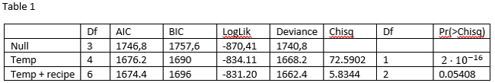

Based on the AIC value the best model was found.

Assumptions for linearity and homoscedasticity were check from the plot below. The assumption of homoscedasticity might be violated.

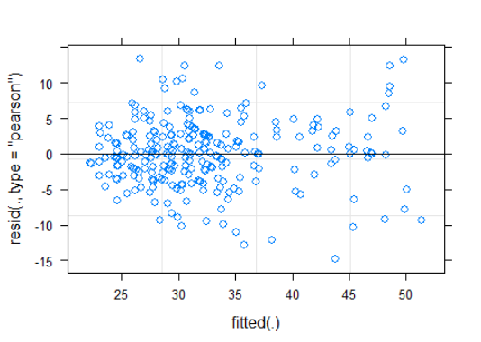

A linear mixed-effects model with angle as the outcome variable and temperature the cake was baked at and the recipe used, were the fixed effects. The model has random intercepts for each time replication. Results in table 2.

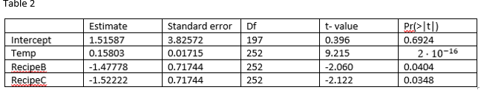

Temperature the cake was baked at, significantly predicted the angle of breakage.  
β=0.16, SE = 0.017, t = 9.2 p < 0.001

Recipe used significantly predicted the angle the cake broke at.

Recipe A vs recipe B

β =-1.48, SE = 0.72, t = -2.1 p < 0.05

Recipe A vs recipe C

β =-1.52, SE = 0.72, t = -2.1 p < 0.05

Analysis 2

Predicting whether someone survived the titanic or not, by using logistic regression, since the outcome variable is categorical. We will be predicting if a person survived based on their sex, age and which class they were traveling on.

Visualization of the data can be seen on figure 1 and the regression output in table 1.

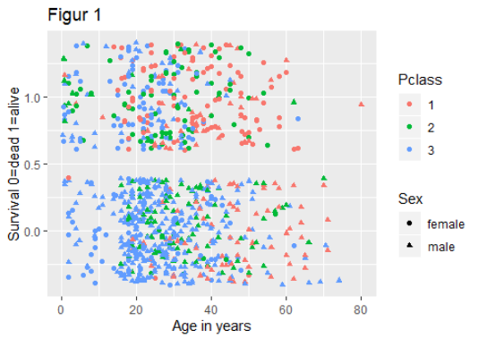

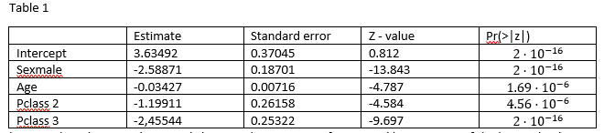

As can be seen in table 1 and in figure 1, being male reduces one’s survival chances, the same goes for age and being in one of the lower class’ compared to class 1.

Probabilities for surviving was calculated with models where only the relevant predictors were involved. Which means that to calculate the probability of survival for a female only sex was assigned as a predictor. The same goes for class. To find the probability of survival given you are a median aged female or male both age and sex were set as predictors:

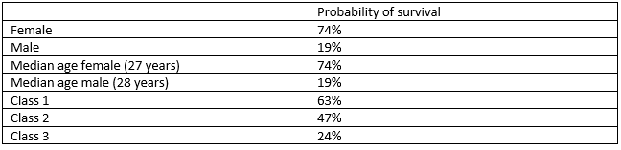

Bonus training:

The logistic model was trained on 75% of the data and tested on the last 25% of the data. The data was split in reverse alphabetic order, from the name column.

When the model was tested on the 25% of observation it had an accuracy of 68%, a sensitivity of 84% and a specificity of 37%.